QUERY 1:
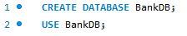
OUTPUT:

QUERY 2:
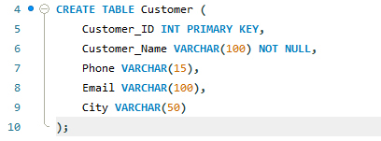
OUTPUT:

QUERY 3:
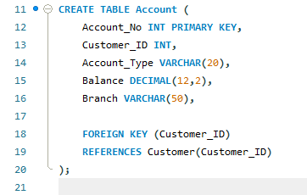
OUTPUT:

QUERY 4:
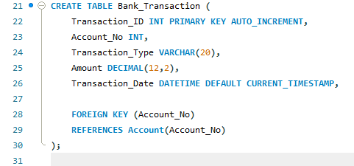
OUTPUT:

QUERY 5:
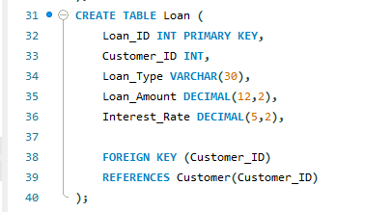
OUTPUT:

QUERY 6:
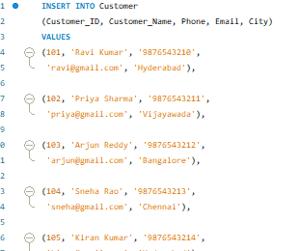
OUTPUT:

QUERY 7:
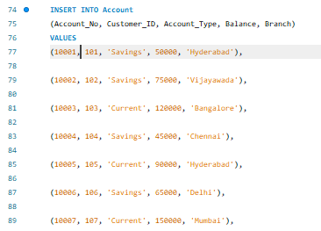
OUTPUT:

QUERY 8:
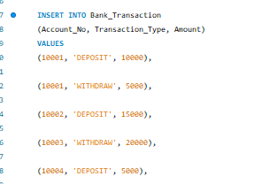
OUTPUT:

QUERY 9:
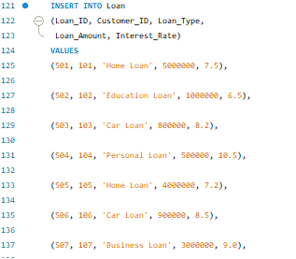
OUTPUT:

QUERY 10:
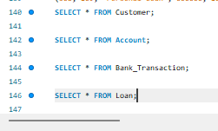

OUTPUT:

QUERY 11:
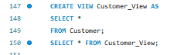
OUTPUT:

QUERY 12:
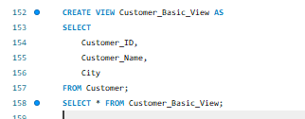
OUTPUT:

QUERY 13:
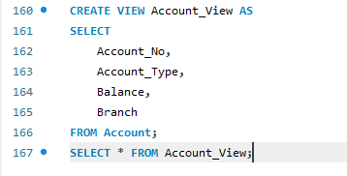
OUTPUT:

QUERY 14:
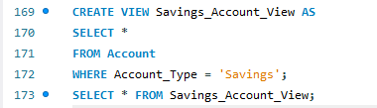
OUTPUT:

QUERY 15:
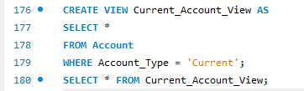
OUTPUT:

QUERY 16:
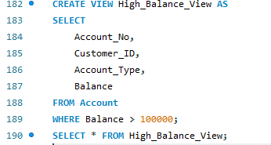
OUTPUT:

QUERY 17:
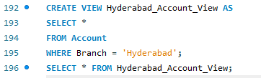
OUTPUT:

QUERY 18:
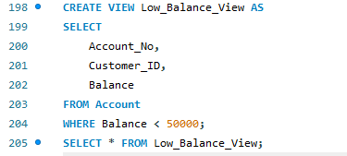
OUTPUT:

QUERY 19:
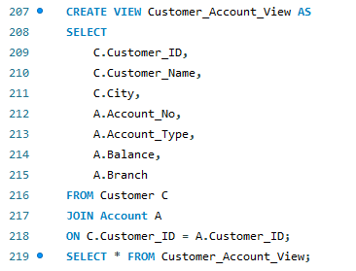

OUTPUT:

QUERY 20:
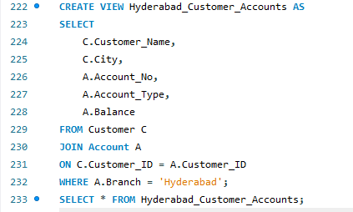
OUTPUT:

QUERY 21:
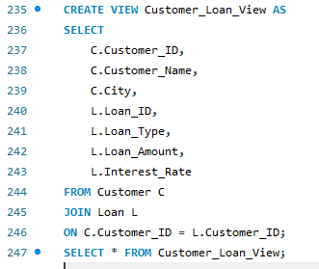
OUTPUT:

QUERY 22:
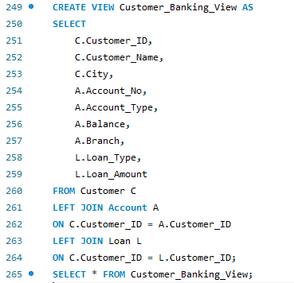
OUTPUT:

QUERY 23:
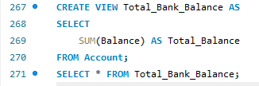
OUTPUT:

QUERY 24:
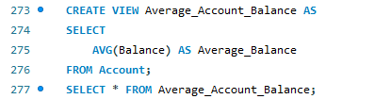

OUTPUT:

QUERY 25:
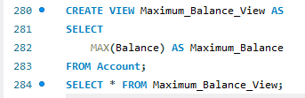
OUTPUT:

QUERY 26:
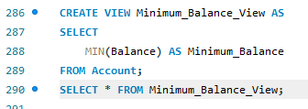
OUTPUT:
QUERY 27:
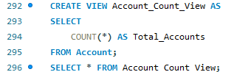
OUTPUT:

QUERY 28:
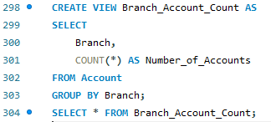
OUTPUT:

QUERY 29:
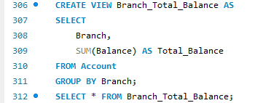
OUTPUT:

QUERY 30:
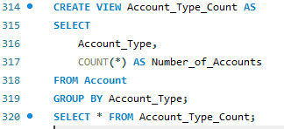
OUTPUT:

QUERY 31:
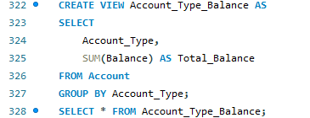
OUTPUT:

QUERY 32:
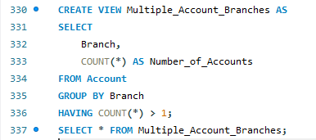
OUTPUT:

QUERY 33:
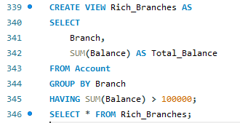
OUTPUT:

QUERY 34:
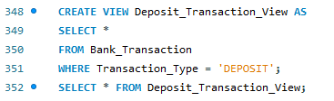
OUTPUT:

QUERY 35:
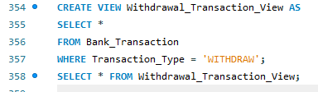
OUTPUT:

QUERY 36:
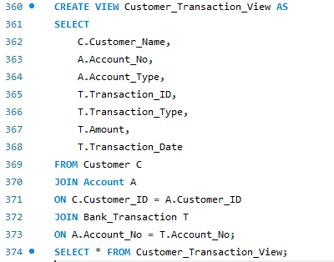
OUTPUT:

QUERY 37:
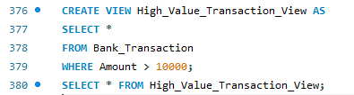
OUTPUT:

QUERY 38:
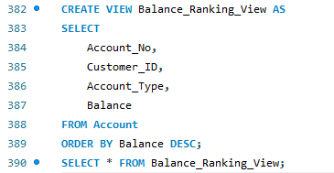
OUTPUT:

QUERY 39:
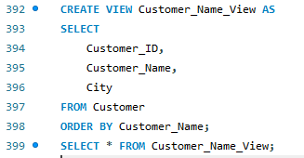
OUTPUT:

QUERY 40:
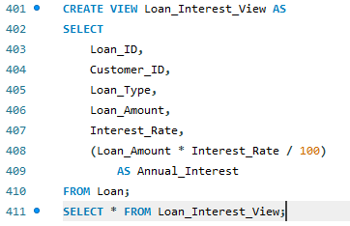
OUTPUT:

QUERY 41:
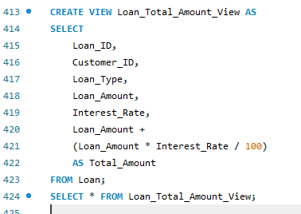
OUTPUT:

QUERY 42:
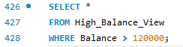

OUTPUT:
QUERY 43:
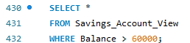
OUTPUT:

QUERY 44:
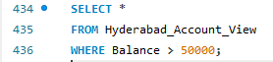
OUTPUT:

QUERY 45:
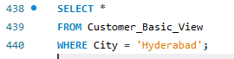
OUTPUT:

QUERY 46:
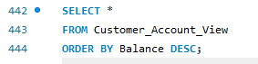
OUTPUT:

QUERY 47:
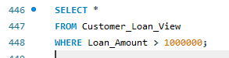
OUTPUT:

QUERY 48:
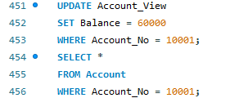
OUTPUT:
QUERY 49:
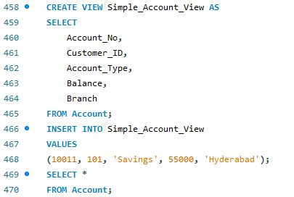
OUTPUT:

QUERY 50:
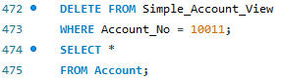
OUTPUT:

QUERY 51:
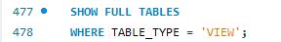
OUTPUT:

QUERY 52:
OUTPUT:

QUERY 53:
OUTPUT:

QUERY 54:
OUTPUT:

QUERY 55:
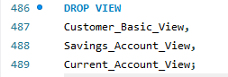
OUTPUT:

